|  |  |
| --- | --- |
| Established in 1879 | RAFFLES GIRLS’ SCHOOL (SECONDARY)  YEAR THREE PHYSICS  Name : ___________________________ ( ) Class : 3_____ Date : ______/17 |

# 

# Tracker Activity Worksheet : Gravitational Potential energy and Kinetic energy

**Aim:** To *feed* yourselves with Physics knowledge by observing the different energy graphs based on the different *menu items* chosen.

***Ingredients* given:** a ping pong ball, a metre rule, a retort stand, a string (at least 1 m), a pendulum bob, a wooden cork, a small wooden block and a wooden ramp

Note: You will also require a video camera (eg. handphone) and Tracker software to record the *appetizing* items that you have *ordered*.

**About our *café*:**

Step 1:In your groups, choose an *appetizer*, an *entrée* and a *dessert (optional)* that you would like to have. Do *eat* them one at a time, starting with the *appetizer*.

Step 2: Once chosen, use the *ingredients* given to set up the scenario. Use only what you need.

Step 3: Use a video camera to record the motion and upload the video clip into a laptop with Tracker software installed. **Do remember to have a calibration stick (i.e. metre rule) in your video.**

Step 4: Move to Appendix A to proceed with tracking and observing the different energy graphs.

Step 5: Payment for your *meal* will be made by submitting a completed report into the relevant google folders of your class.

***Due to high customer demands, you have 30 minutes to complete your meal!***



|  |  |
| --- | --- |
| ***Appetizer 1: Avocado Salsa***  Using the ping pong ball, drop it from a certain height (more than 1 m). Record the motion with a video camera. (Track without the bounce) | ***Appetizer 2:*** ***Stuffed Portobello Mushrooms***  Set up an inclined ramp using the small wooden block and a wooden ramp. Roll the ball from the top of the ramp to the bottom. Record the motion with a video camera. |

**Intermission:** Go to Appendix A to track and observe the kinetic, potential and total energy graphs.

|  |  |
| --- | --- |
| ***Entrée 1: Baked Chicken Parmesan***  Using the ping pong ball, toss it upwards and let it fall down. Record the motion with a video camera. | ***Entrée 2: Honey and Soy Glazed Salmon***  Using the ping pong ball and ensuring that the space in front is clear before throwing, throw the ball in a projectile motion like how you would throw a coin into a pail. Record the motion with a video camera. |

**\*Optional extension:** If you are still *hungry*, you may choose to order a *dessert* too! ;p

|  |
| --- |
| ***Dessert: Molten Chocolate Cake***  Set up an oscillating using a pendulum bob, retort stand, string (length more than 50.0 cm) and wooden cork. Allow the pendulum to oscillate for about 5 swings. Record the motion with a video camera. |

 (Softcopy to be submitted in the Class Google folder)

**Group members: ______________________________________________________**

**Class: ___________________________**

1) *Appetizer* ordered: _____________________________

(Insert KE, PE and TE graphs here)

Comment on the relationship between KE, PE and TE:

2) *Entrée* ordered: _____________________________

(Insert KE, PE and TE graphs here)

Comment on the relationship between KE, PE and TE:

3) *Dessert* ordered(optional): _____________________________

(Insert KE, PE and TE graphs here)

Comment on the relationship between KE, PE and TE:

** Conclusion for today’s *lunch*:**

1) What have you learnt about the relationship between KE, PE and TE? Is TE constant? Why or why not?

2) How has your understanding of the Principle of Conservation of Energy reinforced or changed?

3) What are the implications of Energy in a system?

**Appendix A: How to obtain the KE, PE and TE graphs?**

1) Track the object in the video as how you would track its motion as done before. **Remember to set the length of the calibration stick, the position of the axes and the length of the video that you want to track.**

2) On the right-hand side, select “Plot” to 3 so that you can observe the KE, PE and TE graphs.

3) To obtain the KE graph, select the vertical axis to “K: kinetic energy” as shown below.

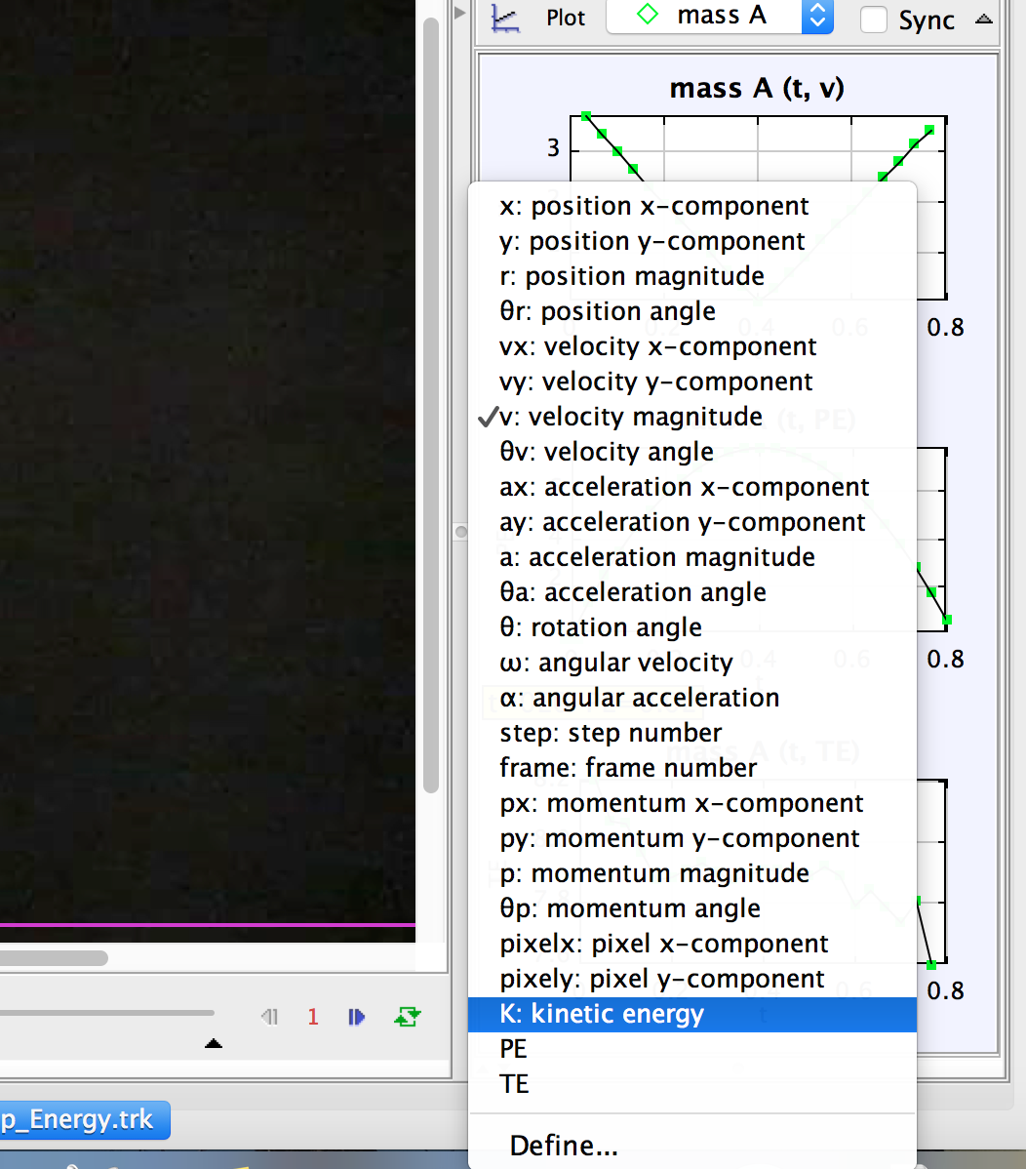

4) To obtain the PE and TE graphs, select the vertical axis and click “Define…” at the bottom (see image above).

5) Once you click “Define…”, a pop up window called “Data Builder” will appear. Set the parameters as shown on the following page:

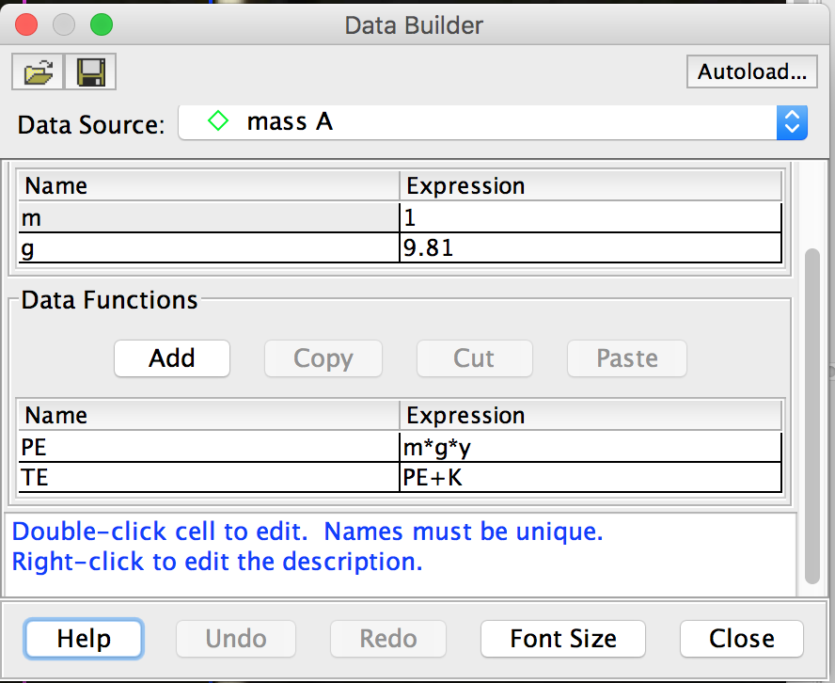

6) All 3 graphs should appear one after the other. Refer to the example below:

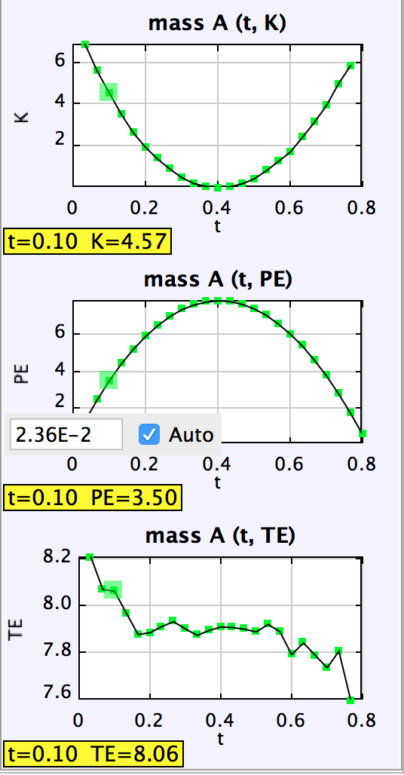

**\*Optional extension**: You may want to compare i) KE graph and Velocity magnitude graphs, and ii) PE graph and vertical displacement, y graphs.